Instructions:
Assessment 3 Report

Word count: 1500

DUE DATE 8th of October 4 pm Melbourne Australia time

Scenario: Amazon is Disrupting Major Supermarkets
As a major player in the digital business space, Amazon has recently decided to enter into the Australian grocery market to compete with Woolworths and Coles. This is mainly done through a reduction in price to undercut the big supermarket chains. Some key facts and figures are presented below:
- Amazon Australia is now undercutting the dominant supermarket chains by as much as 50 per cent on household staples and quickly capturing a foothold in the market
- Some products are priced lower to consumers than the supermarket’s purchase price
- Supermarket giants are worried that brand owners are favouring Amazon as they can offer lower prices to customers (perhaps offering Amazon better terms)
- Selling to Amazon at cheaper prices could adversely impact brands (pricing control and favour with major supermarkets)
- Amazon has less than 1% of the online food and grocery market, which grew 39.7% over last 12 months (Nielsen 2018)
- Amazon.com.au now has more than 2500 food and grocery products on its site
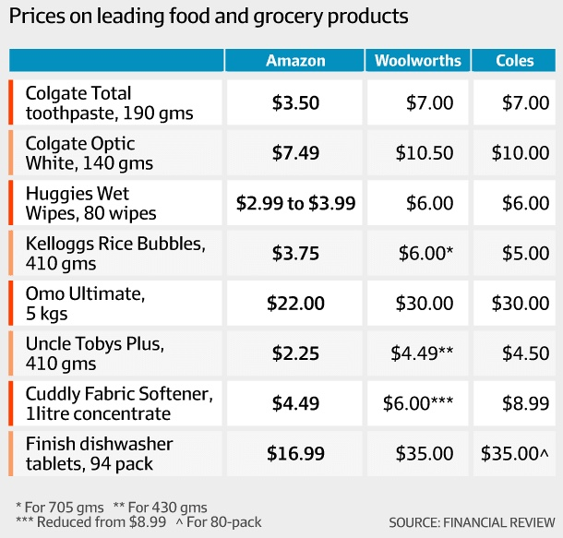

Your task
To adequately compete with Amazon and ensure that they do not take up too much market share, you have been hired as an external consultant by Woolworths to provide a strategy on how they can prepare and compete with Amazon appropriately. Provided below are several internal and external issues that Woolworths are grappling with that need to be solved. These are outlined below:
- Worried shareholders: Shareholders are worried about Amazon’s rise as they see this as a threat to Woolworth’s share price
- Poor online customer service: Woolworths customers have been complaining that when they try and order their groceries online (website and mobile) they can’t sufficiently ask questions and engage with staff members for advice and/or enquiries
- Social media ineptitude: Woolworths are worried that their social media interactions are insufficient and unengaging and that consumers do not have any desire to interact with the brand
- Corporate staff insufficiently trained: The company has identified that not all their staff members are sure of how the online grocery ordering system works. This also extends to payment to suppliers
- Price: Woolworths are unable to compete with Amazon on prices of particular products
- Website not so user-friendly: Amazon’s online ordering system is much more user-friendly than Woolworths
- Distribution: Woolworths has more effective distribution channels than Amazon already set-up in Australia but feel that Amazon is starting to make strong moves in this space. Not only that, but costs for the different buying channels for consumers is higher than simply operating online
- Supplier relationships: Some suppliers are willing to offer Amazon better terms than Woolworths
- Brand reputation: Woolworths has noticed that their reputation is decreasing, and Amazon’s is increasing here in Australia
- Poor consumer loyalty: Consumer loyalty is difficult to establish in the FMCG market and while Woolworths has a large market share, consumers don’t seem to be particularly loyal
As highlighted above, Woolworths have a number of worrying issues they need to deal with and that they see as a threat from Amazon. To assist Woolworths, you need to select 2 issues and develop innovative solutions to dealing with these issues.

What does your solution look like?
- Your solution needs to be innovative and draw on material and theory learned throughout the semester (e.g., we discuss the new consumer decision-making process… how can Woolworths use this?)
- Your solution needs to be a step-by-step implementation guide with control measures highlighted along the process (control refers to different evaluative tools)
- You need to consider costs and timeline (include a realistic budget based on evidence and a timeline of key activities)
- Who in Woolworths should be implementing your solution (their role only…not their name)? Consider if a new role needs to be created, what would this look like?
- Your solution needs to be based on evidence from both business and academic sources. In saying this, if you have a completely innovative solution to a problem that has not been thought of before, then this will be considered

What will you be marked on?
- Two chosen issues and two solutions (one solution to one issue): Each solution is clearly and specifically stated. The solution is logically linked to the problem and is innovative.
- Implementation and control: A thorough and specific implementation plan is clearly identified for every solution.
- Digital business theory: There is a clear integration of relevant digital business theory in solutions (i.e. systems thinking).
- Sources of evidence: High-quality, credible, relevant sources to develop ideas that are appropriate for the development of solutions.
- Writing style: Language is clear and expressive showing a strong writing style and without grammar, punctuation, usage, and spelling errors.

Other instructions
The word count for the report is 1500 words (+10%). You have a short word count which means you do not need to include an executive summary, introduction or conclusion. Instead, your focus needs to be on solutions and how you can best present this to Woolworths’ executives.
Resources that will aid in your research
https://dbb715huzqn8k.cloudfront.net/17/cf/17cf573395e792af8f88832212dbde53692675d5?response-content-disposition=inline%3Bfilename%3D%22G4111%20Supermarkets%20and%20Grocery%20Stores%20in%20Australia%20Industry%20Report.pdf%22&response-content-type=application%2Fpdf&Expires=1633546240&Signature=lU4odoeAcUkhnSTnR6NBEUUl-WQG16iTsKKoxWHaFBg680Ck2ll5rQG4cASIgm0QgRp9Ebl4YMIBSZHffV~G6~~kktPmcd07VvR~oYy1QNOtzsbKE4iX7KZzRHEiitw5N9NiQ0tetyhfgf-o0BsxU4G-kZMqMNcm-UhRlz04OCd1RRGq--FQxWKFmNhbf2-0ITeEZ8KW-V7BpilQEO8OuD8KwBHDrKHtJCrhKt9-7-U2cP9NbcBpMJ-3D0Iode-HXtM~OB8EACctR94sFndbPgJzwc4GnadQmByRuq5sIlZWZp6kNAj8FagvFc3Nij3E8aHMeEt-63ao1dsHbZGBFA__&Key-Pair-Id=APKAJMYMTS3PZ4IMRVZQ
https://www.supermarketnews.com/issues-trends/survey-amazon-top-threat-disruptor-supermarkets
https://www.bloomberg.com/news/articles/2018-03-19/supermarket-casualties-begin-to-pile-up-in- amazon-fueled-battle
https://www.forbes.com/sites/christopherwalton/2018/08/03/in-the-era-of-alibaba-and-new-retail- amazon-go-may-have-a-fatal-flaw-that-limits-its-potential/#541a8c7824f0
http://fortune.com/longform/amazon-groceries-fortune-500/ https://www.marketingmag.com.au/news-c/news-amazon-grocery-pantry-australia/
https://www.news.com.au/finance/business/retail/how-big-an-impact-will-amazon-have-on-australia- maybe-we-should-look-at-what-happened-in-canada-rather-than-the-us/news- story/d546b7a0979f169f9b8160a7f549be0f
https://www.geekwire.com/2016/amazon-go-works-technology-behind-online-retailers- groundbreaking-new-grocery-store/
https://www.woolworths.com.au/shop/discover/shopping-online https://shop.coles.com.au https://www.amazon.com.au/b?ie=UTF8&node=5547635051

